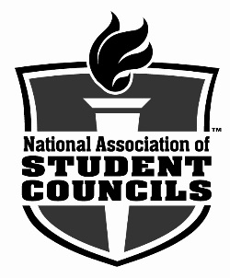
FOR IMMEDIATE RELEASE

April 13, 2015

Palo Verde High School receives national student council award

Las Vegas, NV—For its exemplary record of leadership, service, and activities that serve to improve the school and community, Palo Verde High School student council has been awarded a 2015 National Gold Council of Excellence Award by the National Association of Student Councils (NASC).

“Receiving an NASC National Gold Council of Excellence Award reflects the highest dedication on the part of the school to providing a strong, well-rounded student council program,” said Ann Postlewaite, National Association of Secondary School Principals (NASSP) student programs director. “NASC applauds the work of the National Gold Councils of Excellence and challenges them to continue their leadership and service to their schools and communities.”

“It is an honor to be among 250 recipients of this award nationwide. Our council works hard every day to serve our school and our community, and it is great to be recognized for their hard work.” –Mrs. Caroline Vacante

To meet the requirements for the NASC National Council of Excellence Award, a student council must meet a variety of criteria. In addition to basic requirements such as a written constitution, regular meetings, a democratic election process, and membership in NASC, councils demonstrate things such as leadership training for council members, teacher/staff appreciation activities, student recognition programs, school and community service projects, spirit activities, goal setting, financial planning, and active participation in state and national student council associations. Those councils awarded the gold level have successfully demonstrated the highest levels of leadership.

To learn more about the National Council of Excellence Award, visit www.nasc.us/ncoe.

###

About NASC
Since 1931, the goal of NASC has been to help all student councils become more effective organizations. NASC represents middle level and high school councils nationwide. It creates the opportunity for students to become effective leaders, thus encouraging and influencing a positive school climate. NASC is a program of the National Association of Secondary School Principals (NASSP). For more information on NASC, visit www.nasc.us.

About NASSP
The National Association of Secondary School Principals (NASSP) is the leading organization of and voice for middle level and high school principals, assistant principals, and school leaders from across the United States and 35 countries around the world. NASSP administers the National Honor Society, National Junior Honor Society, National Elementary Honor Society, and National Association of Student Councils. For more information about NASSP, located in Reston, VA, visit www.nassp.org.

School contact:
Caroline Vacante, Student Council Advisor
Phone: (702) 799-1450
Email: cvacante@interact.ccsd.net

